Alexei Belov.

Visiting Professor of Mathematics

Your Research 150 words
My research deals with following fields of mathematics:

- Interlocking structures. For any arrangements of convex figures there is one which can be shifted away without touching others. However, in 3D-space this is not always possible. There exists interlocking structures. They can be used in mechanics. The crack propagation stops on the boundary of grains, from other hand, grains can keep each other. This effect give us new possibility in constructing new materials.

- Polynomial authomorphisms and quantization. The famous Jacobian conjecture has important relations with quantization. The quantization approach, relations between Weil algebra and Poisson brackets is very promising.

3. Polynomial identities and finite basis problem. The Specht problem say whether a given set of identities follows from its finite subset.

2006 highlights 500 words

{\bf Interlocking structures.}
Consider a set of contacting convex figures in R². It is not difficult to prove that one of these figures can be moved out of the set by translation without disturbing others. Therefore, any set of planar figures can be disassembled by moving all figures one by one (as opposed to simple homothetic motion of the plane, which automatically puts the figures out of contact with each other). One may think that this statement holds for higher dimensions as well. However, attempts to generalize it to R³ have been unsuccessful. As a counterexample, structures consisting of convex solid bodies which cannot be disassembled by removing individual bodies were suggested in Ref. [1].

Consider an infinite layer of cubes. The middle section of the layer produces a square lattice. Let us color the section in a checker board fashion. Now, we alter the inclinations of lateral faces of the cubes pair wise. Consider for instance a ‘black’ cube, i.e. a cube associated with a black cell of the lattice ( Fig. 1). Incline the ‘north’ and ‘south’ faces of the cube outwards at an angle α, together with the faces of the two adjacent cubes, cf. Fig. 1, where the faces are sketched. With a proper choice of the angle α, a cube is transformed to a tetrahedron and the entire layer turns into an assembly of interlocked tetrahedra, Fig. 2.

Figure 1. Modification of cube faces. The arrows show the sense of the inclinations of the modified faces.

Figure 2. Fragment of interlocking set of tetrahedra.

The appropriate inclinations of the faces of the constituent elements are the key feature of interlocking structures.

The above structure provides an example of an assembly in which no element can be removed without disturbing its neighbors. It is appealing to use such arrangements in engineering as a new design principle. This principle allows one to build structures of convex elements without a binder phase or connectors, i.e., structures which (a) possess high resistance to fracture propagation (fractures getting stopped at interfaces between the elements) and free of stress concentrations associated with mechanical connectors used in conventional assemblies of building blocks [3-7]. Thus, there is a practical need to find and characterize interlocking sets.

The structures described are obtained by tiling the plane with equal squares. A.J. Kanel-Belov considered another regular tiling - the hexagonal (honeycomb) one and found a new type of interlocking solids, which turn out to be simple cubes!

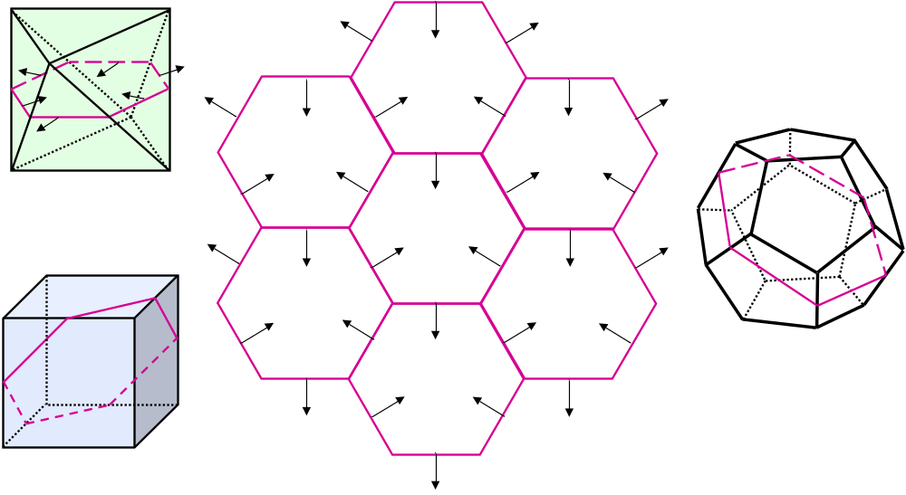
Figure 3. Hexagonal tiling of the plane and the associated platonic solids with their respective hexagonal middle sections. Orientations of arrows indicate the inclinations of faces of the modified hexagonal prisms that provide their interlocking.

Figure 4. Fragment of interlocking set of cubes.

Figure 5. Fragment of interlocking set of octahedra.
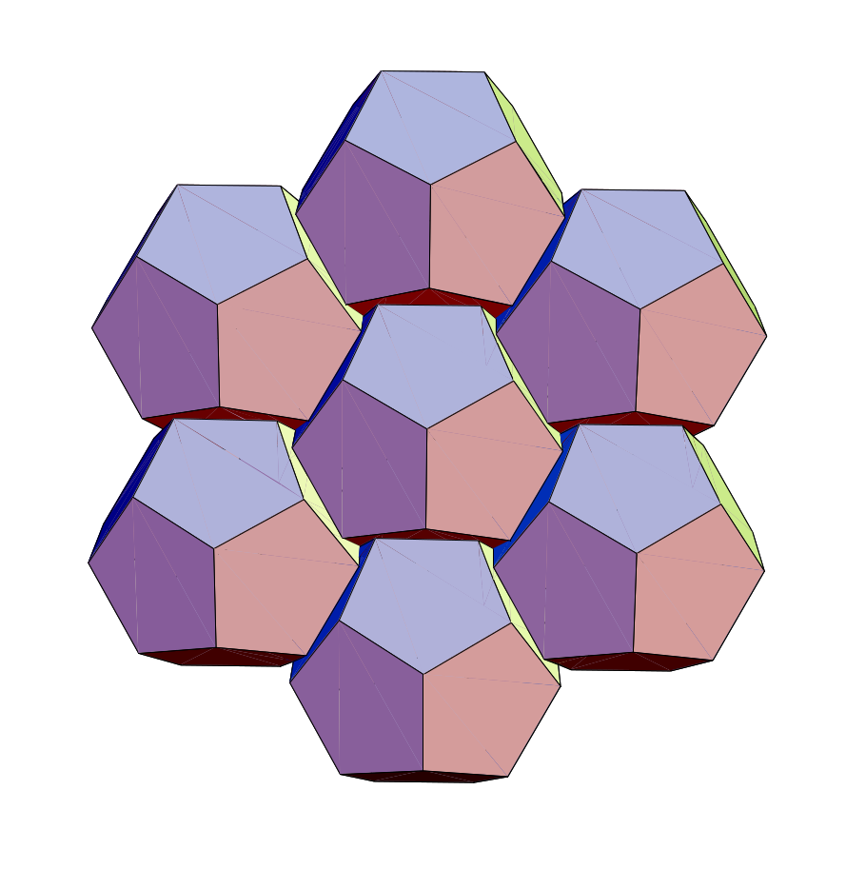

Figure 6. Fragment of interlocking set of dodecahedra normal to the symmetry axis of 3rd order.
.
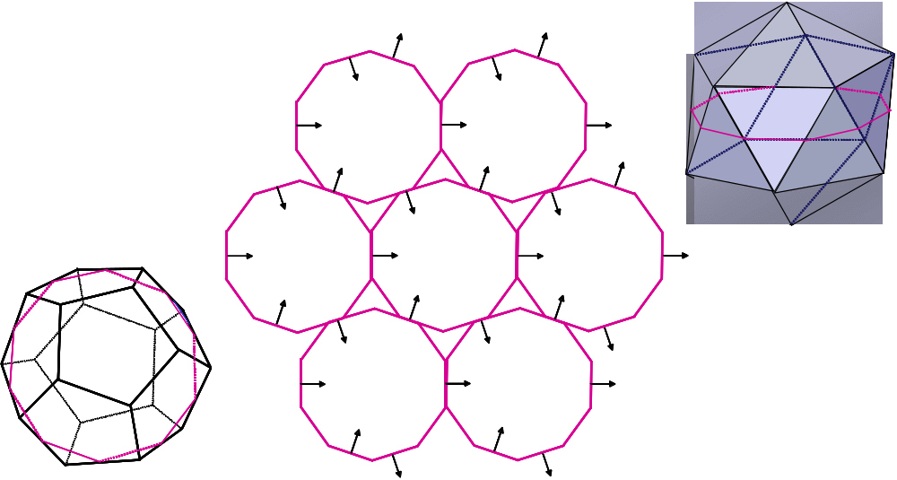
Figure 7. Decagonal tiling of plane and the associated dodecahedron and icosahedron. Only arrows that correspond to contacting faces are shown.
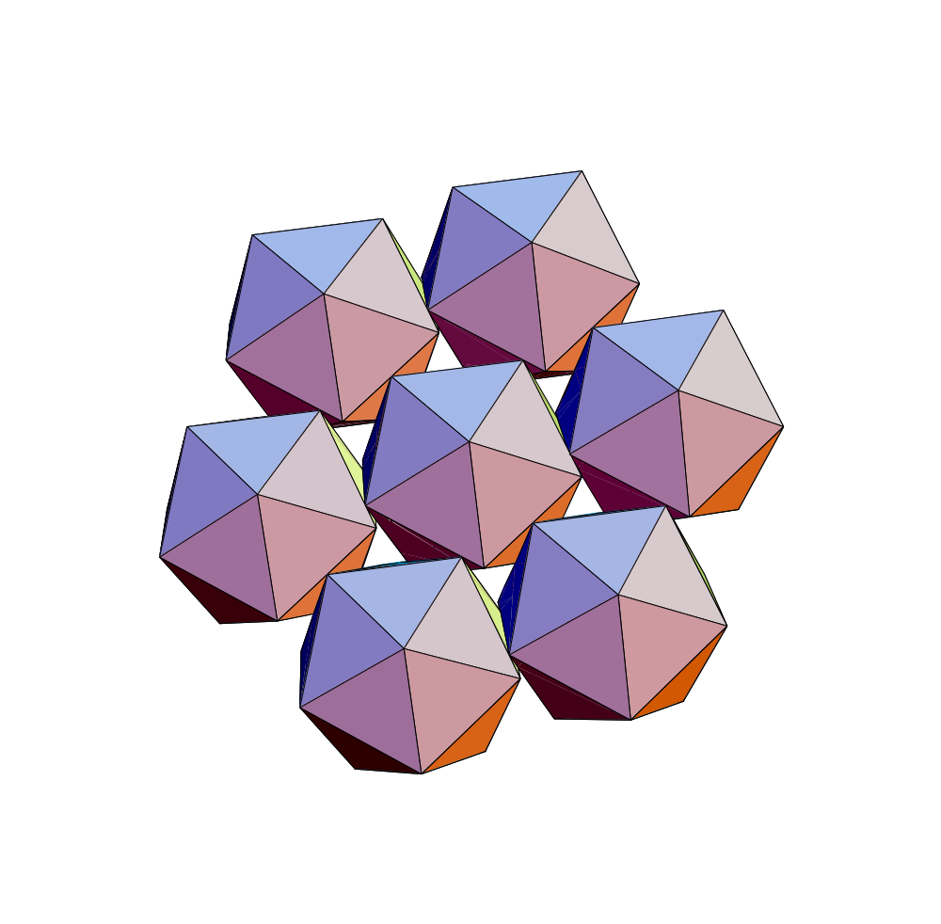
Figure 8. Fragment of interlocking set of icosahedra

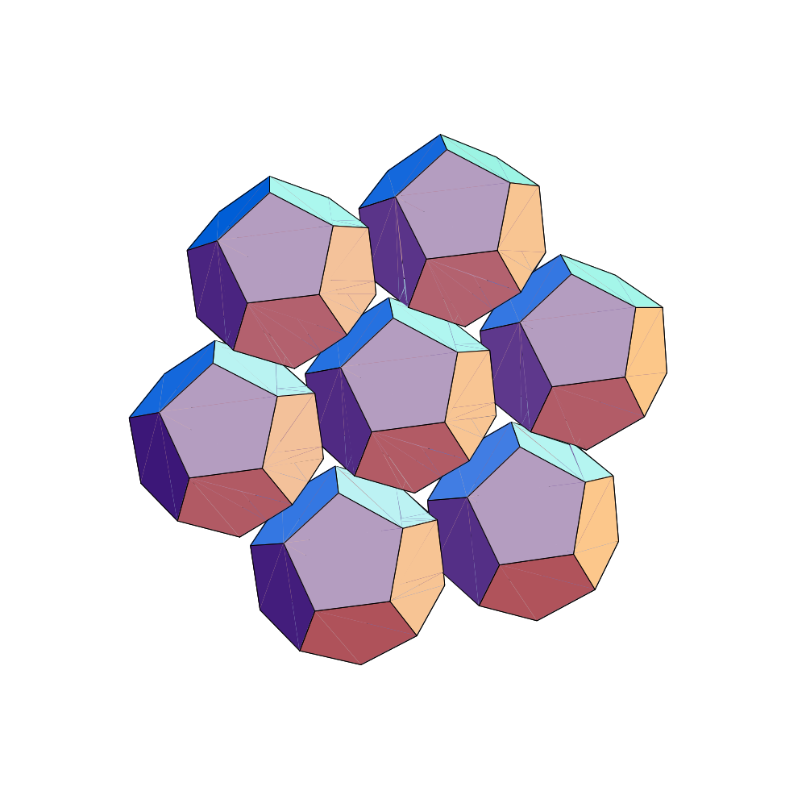
Figure 9. Fragment of interlocking set of dodecahedra normal to the symmetry axis of 5th order.
The diversity of interlocking arrangements of regular convex polyhedron uncovered so far suggests that there might be a whole wealth of such structures beyond the examples presented. These structures, as well as conventional masonry structures, cracked solids, blocky rock masses and some asteroids and comets are all examples of fragmented bodies. Considerations presented show a way to develop a geometric theory of fragmented bodies. Such a theory could also shed light on some interesting natural phenomena, e.g., the integrity and mechanics of flexible sandstones (e.g., [10]) or ancient building techniques, like dry stone walling (e.g., [11]) and may have some exciting engineering applications, such as a new concept of protective tiles for Space Shuttle [12].

1. Gal’perin, G.A., 1985, Russian Math. Surveys, 40, 229.
2. Kanel, A. Ya., 2001, A story of an olympiad problem, Matematicheskoe prosveshchenie, 3, No. 5, 207-208 (in Russian).
3. Dyskin, A.V., Y. Estrin, A.J. Kanel-Belov & E. Pasternak, 2001. A new concept in design of materials and structures: Assemblies of interlocked tetrahedron-shaped elements. Scripta Materialia, 44, 2689-2694.
4. Dyskin, AV, Y Estrin, A J Kanel-Belov & E Pasternak, 2001. Toughening by fragmentation - How topology helps. Advanced Engineering Materials, 3, Issue 11, 885-888.
5. Estrin, Y., Dyskin, A.V., Kanel-Belov, A.J. & Pasternak, E. 2002. Materials with novel architectonics: Assemblies of interlocked elements. In B. Karihaloo (ed.) IUTAM Symposium on Analytical and Computational Fracture Mechanics of Non-homogeneous Materials, Kluwer Academic Press, 51-56.
6. Khor, C., Dyskin, A.V., Pasternak, E. Estrin, Y. and Kanel-Belov, A.J. 2002. Integrity and fracture of plate-like assemblies of topologically interlocked elements. In: Structural Integrity and Fracture, SIF2002 (Dyskin, A.V. Hu X.Z. and Sahouryeh, E., Eds), Swets & Zeitlinger, Lisse, 449-456.
7. Dyskin, A.V., Estrin, Y., Kanel-Belov, A.J. and Pasternak, E. 2003. Topological interlocking of platonic solids: A way to new materials and structures, Phil. Mag. Letters Vol. 83, No. 3, 197-203.
8. Glickman, M. 1984. The G-block system of vertically interlocking paving, In: Second International Conference on Concrete Block Paving, Delft, April 10-12, 1984: 345-348.
9. Kanel, A. Ya., 2003, Interlocking of cubes, Matematicheskoe prosveshchenie, to be published.
10. Dusseault, M.B. 1980. Itacolumites: the flexible sandstones. Q.J. eng. Geol. London, 13, 119-128.
11. Radford, A. 2001. A Guide to Dry Stone Walling. The Growood Press Ltd., Ramsbury, Marlborrough, Wiltshire.
12. Estrin, Y., A.V. Dyskin, E Pasternak, H.C. Khor & A J Kanel-Belov 2003. Topological interlocking of protective tiles for Space Shuttle. Phil. Mag. Letters, 83, 351-355.
13. Estrin, Y., A.V. Dyskin, E Pasternak, I.Molotnikov & A J Kanel-Belov 2003. Percolation mechanism of failure of a planar assembly of interlocked osteomorphic elements
Engineering Fracture Mechanics.

14. Interlocking of convex polyhedra: towards a geometric theory of fragmented solids. A.J.Kanel-Belov, A. V. Dyskin, Y. Estrin, E. Pasternak, I. A. Ivanov. To appear in Moscow mathematical Journal.

2. Jacobian Conjecture and quantization.

Let $F: {\bf C}^n\to {\bf C}^n$ be a polynomial mapping. If it is invertible, then it is locally invertible. Local invertible properties means that Jacobian matrix of mapping $F$ is non-zero constant.

The is well-known {\bf Jacobian Conjecture $(JC_n)$} says that this sufficient condition. This conjecture is still unsolved since 1934.

Let $W_n$ be an algebra of polynomial differential operators of $n$ variables over complex field. The {\bf Dixmier conjecture $(DC_n)$} says that {\it every endomorphism of $W_n$ is an authomorphism}. This conjecture is open since 1967.

Recently A.J.Belov and M.L.Kontsevich proved an equivalence between these conjectures (another proof was independently obtained by Y.Tsuschimoto).

The idea of proof is based on the reduction to positive characteristics and consideration of the poisson brackets on the center of Weil algebra modulu $p$.

This new approach to studying polynomial authomorphisms is based on quantization. Let $A$ be an assosiative commutative algebra endowed with Poisson brackets. Kontsevich quantization theorem says that there exists a deformation $*$ of multiplication in $A[[h]]$ such that $x*y $
is equivalent $xy \mbox{mod} h$, and $(x*y-y*x)/h$ is equivalent to $\{x,y\}$.

The Weil algebra is quantum space. It is result of quantization of polynomial ring via standart Poisson bracket. There is a Kontsevich conjecture that group of polynomial authomorphisms of ${\bf C}^n$ isomorphical to the group of authomorphisms of Weil algebra. It means equivariant properties of quantization.

In the proof of equivalence between Jacobian and Dixmier Conjectures the homomorphism between these two groups was constructed. It is important to notice that we use deformation in arithmetical direction (prime number plays role of plank constant).

1. Belov, A.; Kontsevich M.L. Automorphisms of Weil algebras.
Letters in Mathematical Physics, vol. 74 (A special volume dedicated to
the memory of F.A. Berezin), issue 3.

2. Belov, A.; Kontsevich M.L. Jacobian and Dixmier Conjectures are stably equivalent.Moscow Mathematical Journal.
to appear.(posted in ArXive).

3. Belov, A., Berzins A., Lipiansky R. Automorphisms of endomorphism group of free associative algebra. Int. Journ. of Algebra and Appl.
(posted in ArXive).

4. Belov, Alexei; Makar-Limanov, Leonid; Yu, Jie-Tai. On
generalized cancellation problem. J. Algebra 281 (2004), no. 1,
161--166.

5. Belov, Alexei; Yu, Jie-Tai.
Cancellation problems and dimension theory.
Comm. Algebra, 34 (2006), no. 4, 1521--1540.

3. Polynomial identities and Specht problem.

The polynomial identity of an algebra A is a polynom which vanish on this algebra. Identity g is corollary from set of identities ${f_i}$ if any algebra, which satisfy system ${f_i}$ satisfies also $g$.

Many classes of algebras (such that associative, Lie, Jordan, alternative algebras) can be axiomatized as a class algebras satisfying some identities. The Specht problem says that whether every set of identities is corollary of its finite subset.

In characteristic 0 the answer is YES, as was shown by A.Kemer. In general, answer is NO, it was shown by A.Belov. But if number of generators is bounded, then answer is YES, as was shown by A.Belov.

The last result was recently accepted by Izvestia of Russian Academy of Science.

The Specht problem related to the theory of pro-p-groups and non-associative rings.

1. Belov A.J. Varieties of assosiative algebras locally finitely based and locally representable. Isvestia RAN, to appear.

2. Belov A.J. On the rings which are assymptoticaly near assosiative. Siberian Adv. In math.

3. Belov A.~J. Counterexamples to the Specht problem.
Mat. sb., 1999, vol. 191, N 3, p.13--24.
(Engl. transl. Sbornik: Mathematics 191:3,
329-340.)

4. Belov A.~J. Algebras with polynomial identities: representations and combinatorial methods. Dr.Sci. thesis.,--- Moscow, 2002, pp. 389.

5. Kanel-Belov, Alexei; Rowen, Louis Halle. Combinatorial
aspects in polynomial identities. Research Notes in
Mathematics, 9. A K Peters, Ltd., Wellesley, MA, 2005. xxii+378

6. Belov A., Borisenko V., Latyshev V.
Monomial algebras.NY, Plenum. 1998,
p. 5 -- 190.J.Math.Sci., NY, 87, 1997, no3, pp.3463--3575

Organization

International university Bremen,
Moscow institute of open education.
Bar-Ilan University,

Collaborations
I have describreed belloow each topivc and pointed collaborators already.

1. M.L.Kontsevich. professor of IHES, Bures sur Yvette.
(polynomial authomorphism theory).

2.Yu, Jietai. Associated prof. Hong-Kong University.
(polynomial authomorphism theory).

3.L.Makar-Limanov, prof. Wayne State University Detroit, MI 48202, USA.
(polynomial authomorphism theory).

4. Efim Zelmanov, prof. of mathematics, university of California, San-Diego.
(polynomial authomorphism theory)

5. L.Rowen, prof of Bar-Ilan University, Israel.
(polynomial Identities and Specht problem)

6. U.Visshnu associate prof of Bar-Ilan University, Israel.
(polynomial Identities and Specht problem)

7. V.N.Latyshev professor of Moscow State University, head of Algebra dept.
(polynomial Identities and Specht problem)

8. A.V.Michalev prof. of Moscow State University, vice-president.
(polynomial Identities and Specht problem)

9. A.V. Dyskin, prof. School of Civil and Resource Engineering, The University of Western Australia
(interlocking structures).
10. Prof. Dr. rer. nat. habil. Juri Estrin
Technische Universität Clausthal
Lehrstuhl für Physikalische Werkstoffkunde
Agricolastr. 638678 Clausthal-Zellerfeld
(interlocking structures).
11. Elena Pasternak, lecturer, school of math. The University of Western Australia.
(interlocking structures).
- Ilia Ivanov. Ph. Dr. Moscow state university.

(interlocking structures).

Grants

- Israel Science foundation, Grant “polynomial Identities” No 1178/06.

Patents
Not

Awards, Pizes
I have sent a cv (can do it once more) if something is useful, then fine.

- [enumerate your content here]

Publications

I have send a list of publications already.

- [list your publications here, please use a BibTeX like classification. You can look up which classifications are available as well as an example at http://en.wikipedia.org/wiki/BibTeX ]

Scientific visits in the last year:

1. Harish-Chandra Research institute. Alahabad, India. October 2006.

2. Institute des Hautes Etudes (Paris). May 2006, July 2006.

